Contents

Use Cases 2

1. Login 2

2. Home Page - General information page 3

3. Add new user 3

4. Buddy Role and Responsibilities 7

5. Sent mail to User 8

6. Send mail to buddy 8

7. Update user data 8

8. Check list for new users 10

9. Users in department 12

10. Export user’s information in Excel 13

11. Tutorials 13

12. Leave check list 14

13. Remove user 15

# Use Cases

## Login

To access the application, the username and the right password must be provided. The username consists of user’s first name and last name.

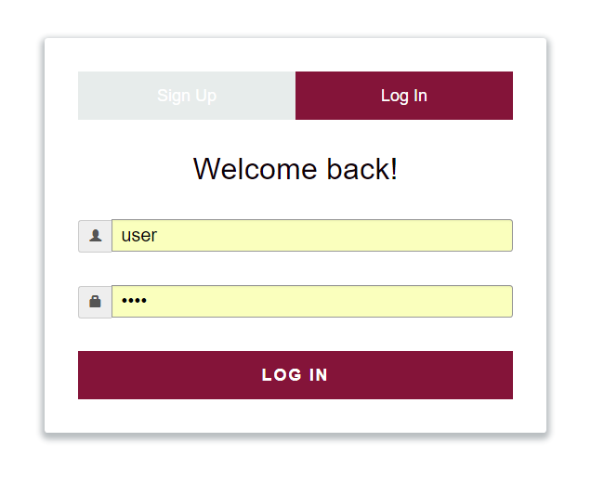

## Home Page - General information page

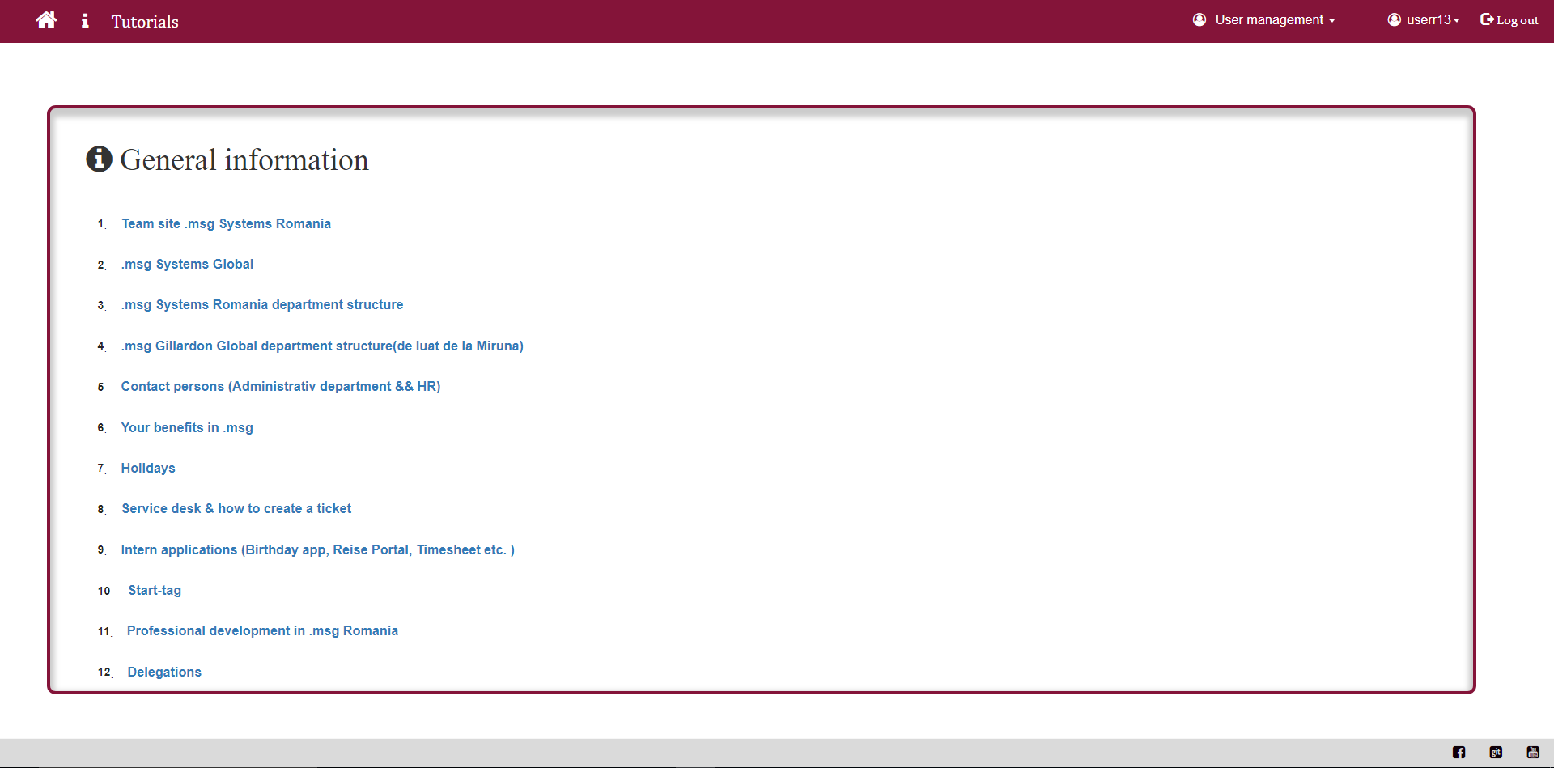

The homepage is a collection of useful links for a new user, such as:

* Team site Romania
* Department structure
* Benefits
* Service desk
* Intern applications (Birthday app, Reise Portal, Timesheet)
* Holidays
* Delegations
* Start-tag

## Add new user

The add new user functionality is only available for specific users. A HR user or an ABTEILUNGSLEITER user can add a new user to the application.

The Add new User option is available under the “User Management menu” from the upper right corner:

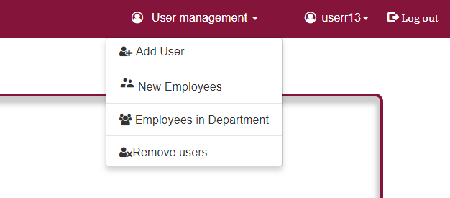

To add a new user a new window will appear:

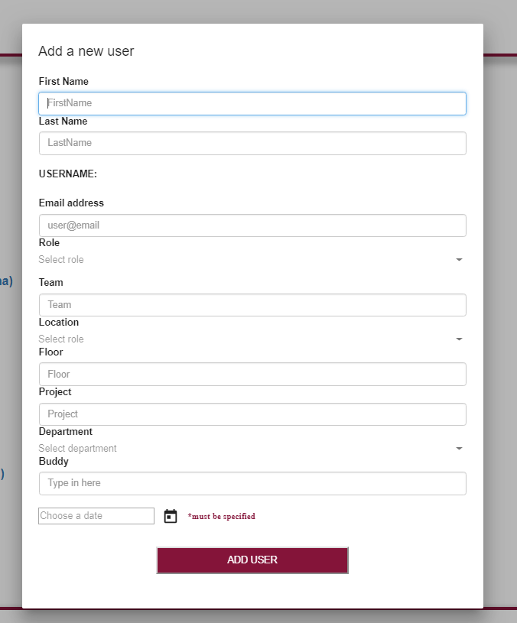

Some of the information from the form are mandatory:

* First name and last name to generate the username
* Personal email address for the application to send an automatic email to new user a week before his start data
* User’s role
* And the start date

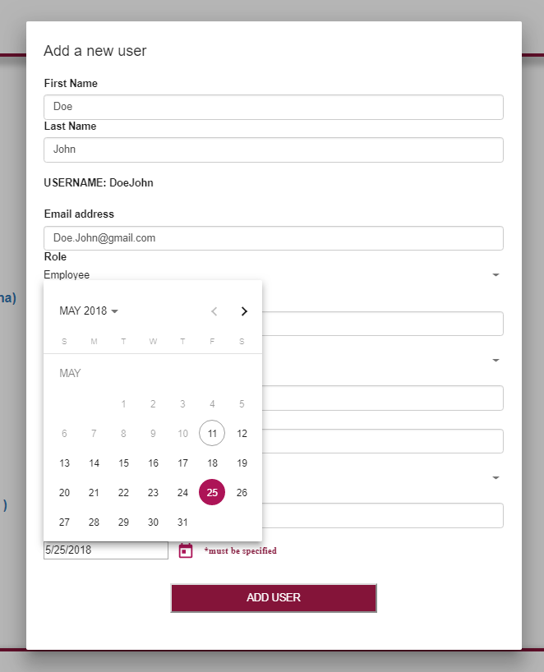

It would be good if all the information were completed so the system could send the automatic email.

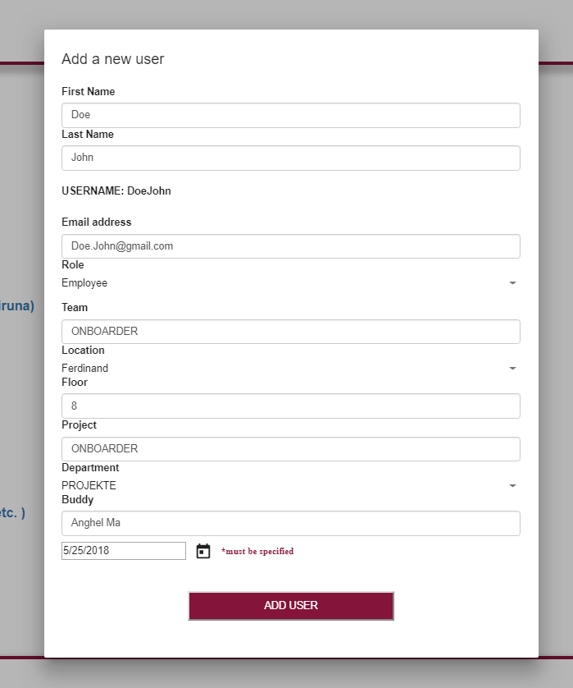

## Buddy Role and Responsibilities

Every new user will have a buddy assigned. A buddy will inform his colleague about anything. A list of all his responsibilities can be found in the “User menu”, option “Buddy TO DO List”.

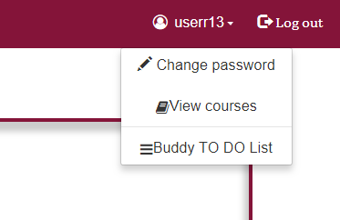

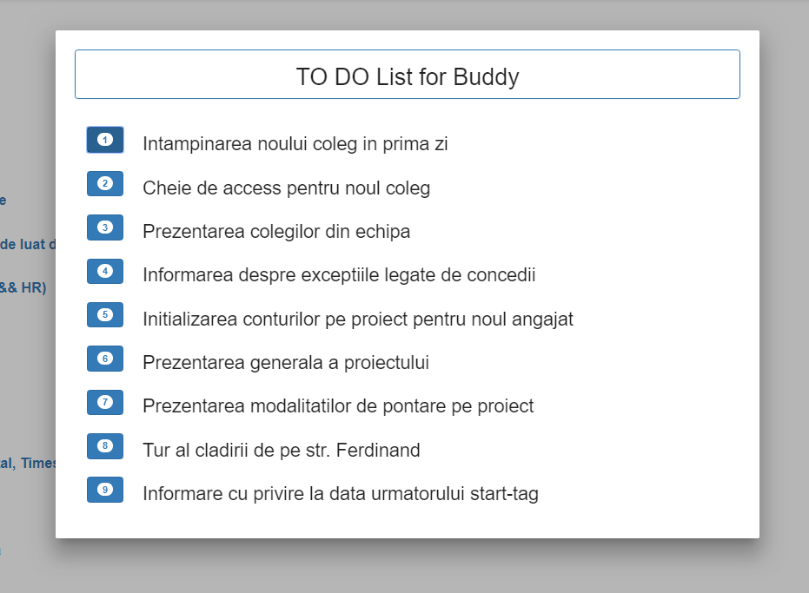

## Sent mail to User

For every new user added in the application, an automatic email will be send a week before his start date. The email contains useful information for a new employee such as:

* Address of the location at which the user is expected
* Date and hour for his expected arrival time on his first day
* The person who will wait him (his buddy)
* Information about the team and project

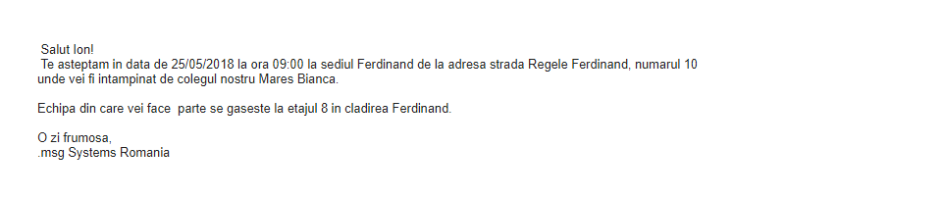

## Send mail to buddy

When the new employee receives the email, his buddy will also receive an email to inform him about the arrival time and date of the new colleague and at the same time to remind him about some responsibilities that he will have.

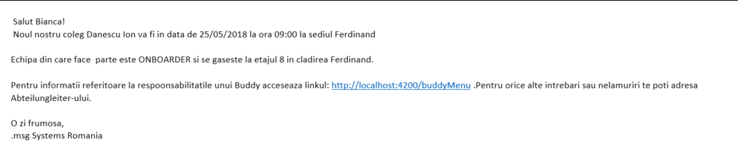

## Update user data

The update user information option is available under the “User management“ menu, in “New Employees” option.

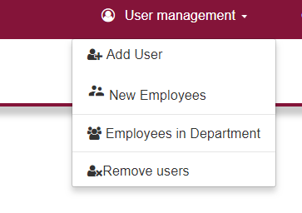

Update user data option is only available if the automatic email was not sent. The email will not be sent if user information is missing.

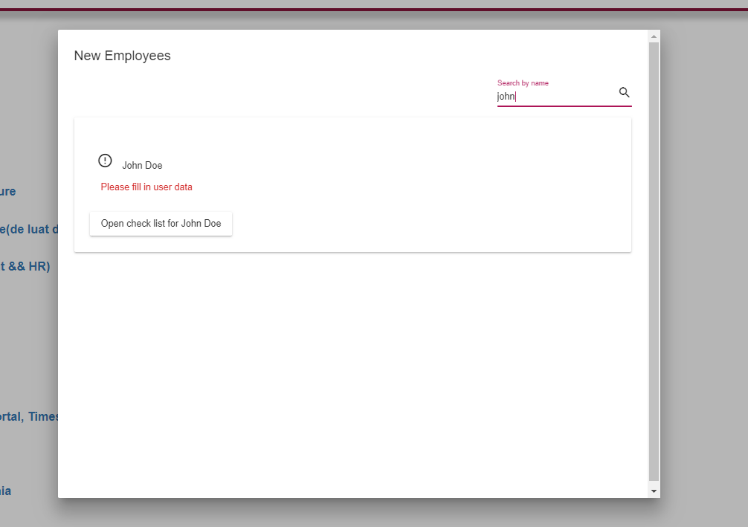

To update user information select “fill in user data”.

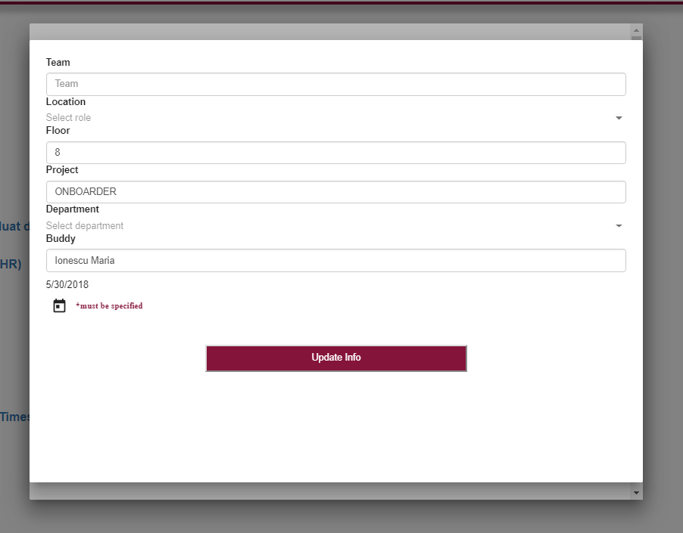

To save the updated information select “Update info”.

## Check list for new users

Every new employee has a checklist assigned, which contains the things that need to be ready before the new employee starts working. The list contains:

* Laptop order: if the laptop order was made
* Password: if the initial password is known
* Mail sent to user: checked automatically when the mail is sent to the user
* Mail send to buddy: checked automatically when the mail is sent to user’s buddy
* Buddy assigned: check by the Abteilungsleiler when the user has a buddy assigned

The checklist is also available in the “New Employee” window as the “Update user information” option.



For example, to open the checklist for the new user Doe John a user must select “Open check list for Doe John”.

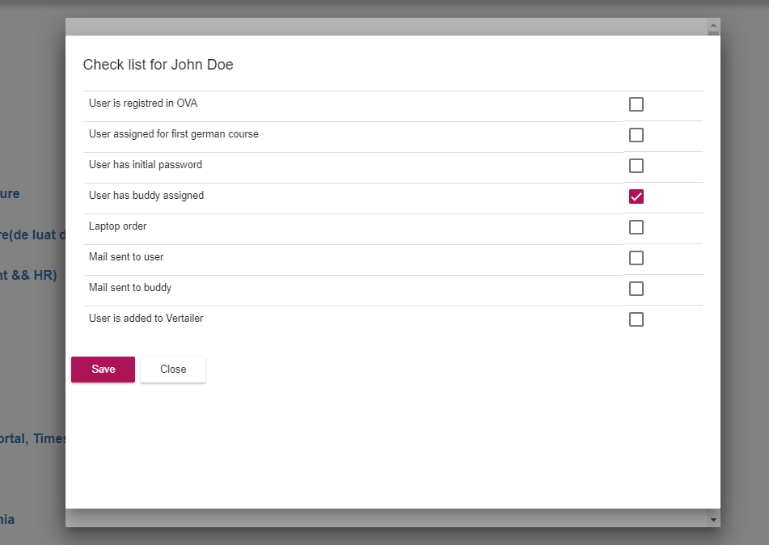

After all items are set the user can select “Save”.

## Users in department

This option is available for a user with Abteilungsleiter role. This functionality allows the user to see a full list of employees in the department he / she is, to look for specific employees and view details.

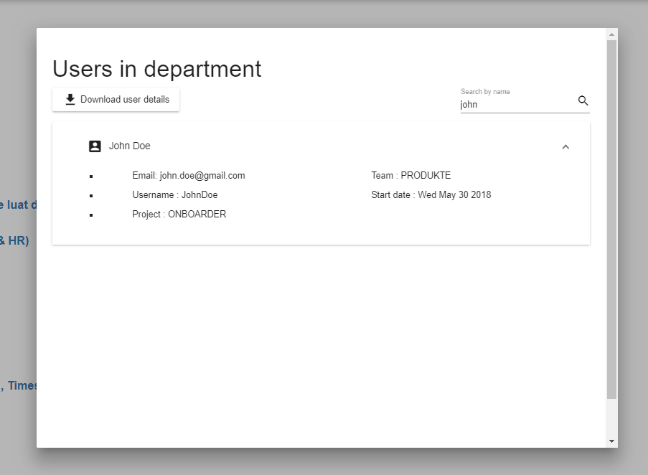

## Export user’s information in Excel

In the same window as “User in department” an Abteilungleiter can export user’s information in excel. By clicking the “Download user details” a file wil start downloading. The Excel file contains:

* Employee name
* Email
* Username
* Start date
* Team
* Project

## Tutorials

## Leave check list

The leave checklist represents all things that need to be done before a user leaves the company. The Abteilungleiter can check the items one by one and save the status of the list or all at once.

A user can not be removed from the application if there is at least one item unchecked. An error message will appear.

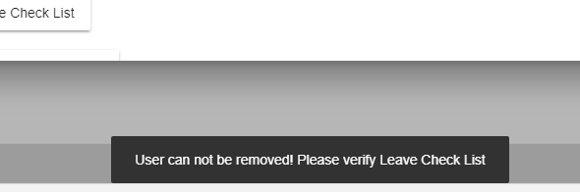

To open the check list first the user has to go to “Remove user” menu.

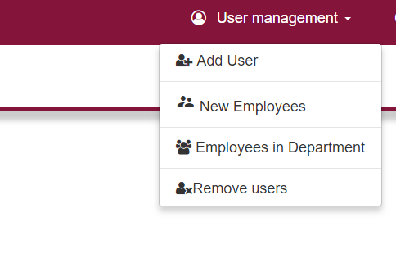

In the “Delete Employee” window a user can be search by name and then click “Open Leave Check List” option.

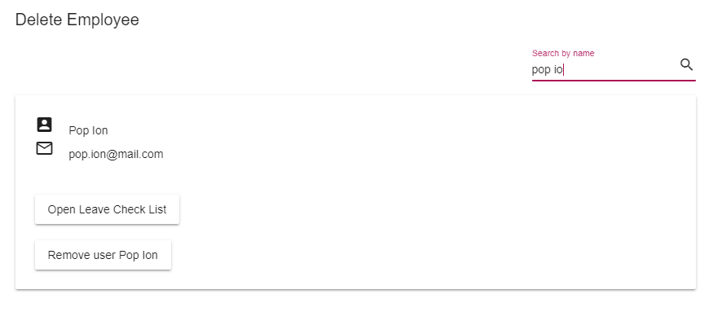

After the check list window is displayed an Abteilungleiter can check one or more items and click on Save button to save the list.

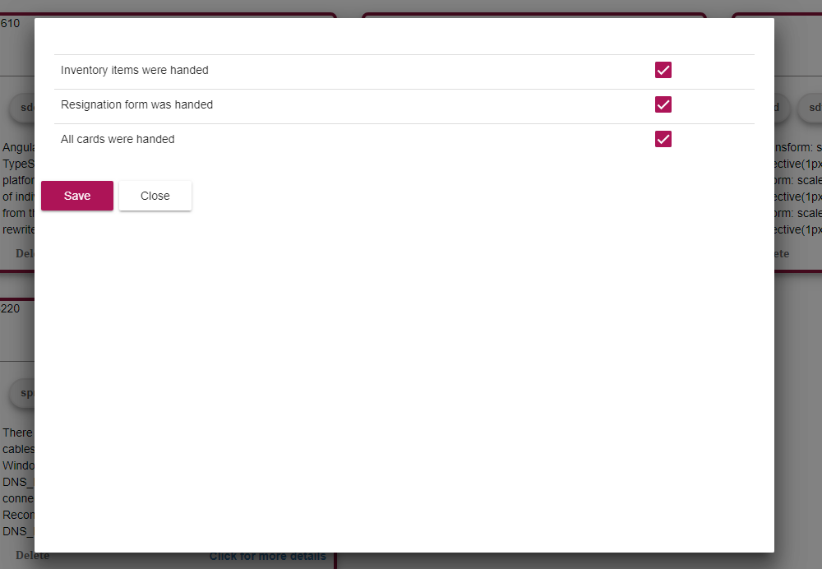

## Remove user

When a user is removed from the application the Leave checklist must be completed. After all checkpoints are met an Abteilungleiter user can press the “Remove user” button and all information about the user will be removed from the database.

